17th Annual Gathering Registration
15-20 May, 2018
New Orleans, LA
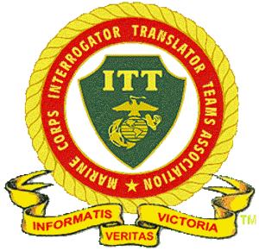

Name
Mailing Address City, State, Zip +4

Email Address Telephone Number
Name of Spouse Attending Name of Guest(s) Attending

When | What | Number | Total
Wed 05/15 | 1200: Hospitality Room open  1500: Arrive/Check in – Registration-$50.00 per person  1800: Hors d’ Oeuvres and Entertainment
Thur 05/16 | 0930: Boutique Shopping/Cellar 53 Winery Tour and  Lunch. Return to Hotel. $46 each  1600: Board Bus-Dinner on your own  Following Dinner: Ryman Auditorium Show: $112 each  2100: Return to hotel
Fri 05/17 | 0800: MCITTA Business Meeting  1030: Board Bus to Sammy B’s/Veterans Museum  1100: Lunch outing  1330: Memorial Ceremony/Museum Tour  1500: Return to hotel  1630: Board bus to AG Center  1700: Flag Ceremony  1830: Catered Dinner  2000: Board bus for return to hotel  All inclusive for the day: $75 each
Sat 05/18 | 0800: Board bus to Studio B  0900: Tour and Recording  1000: Board bus-Country Music Hall of Fame  1030: Lunch on your own & tour Museum $92 each  1300: Return to hotel  1730: Board bus for General Jackson Showboat $88 each  2200: Board bus for return to hotel
Sun 05/19 | Open Day-  1800: Banquet at hotel: Included in Registration
Mon 05/20 | 0800-TBD-Farewell Breakfast/Goodbyes until next gathering
Note: | Make checks to MCITTA. Mail to:  Jack Parker 12479 S Ironwood Dr., Yuma, AZ 85367 | TOTAL
Donations for operation of MCITTA are tax deductible and gratefully accepted
Fairfield Inn & Suites Lebanon, TN - Direct Line: (615) 470-2224
$119 plus taxes and fees for standard room. $139 plus taxes and fees for suite. Cut off date for reserving rooms is 16 April. Please make reservations early.

